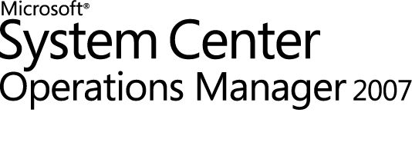
Microsoft Amalga UIS 2009 Management Pack
Release Notes
Microsoft Corporation

Copyright
Information in this document, including URL and other Internet Web site references, is subject to change without notice. Unless otherwise noted, the companies, organizations, products, domain names, e-mail addresses, logos, people, places, and events depicted in examples herein are fictitious. No association with any real company, organization, product, domain name, e-mail address, logo, person, place, or event is intended or should be inferred. Complying with all applicable copyright laws is the responsibility of the user. Without limiting the rights under copyright, no part of this document may be reproduced, stored in or introduced into a retrieval system, or transmitted in any form or by any means (electronic, mechanical, photocopying, recording, or otherwise), or for any purpose, without the express written permission of Microsoft Corporation.
Microsoft may have patents, patent applications, trademarks, copyrights, or other intellectual property rights covering subject matter in this document. Except as expressly provided in any written license agreement from Microsoft, the furnishing of this document does not give you any license to these patents, trademarks, copyrights, or other intellectual property.
© 2009 Microsoft Corporation. All rights reserved.
Microsoft, MS-DOS, Windows, Windows Server, and Active Directory are either registered trademarks or trademarks of Microsoft Corporation in the United States and/or other countries.
All other trademarks are property of their respective owners. A complete listing of Microsoft trademarks can be found at http://www.microsoft.com/library/toolbar/3.0/trademarks/en-us.mspx.

Contents
Copyright 1
Contents 2
New Features and Fixes 2
Outstanding Issues 2
Windows Server 2008 2
Microsoft System Center Operations Manager CPU Usage on Clusters 3
Customer Feedback Issues 3
Outstanding Issues 3

New Features and Fixes
Following is a list of features and fixes included in the Release of Amalga Management Pack. These are changes that have occurred since the private technical preview was released in April 2009. Please refer to the Microsoft Amalga UIS 2009 Management Pack for a listing of management pack functionality and the Amalga UIS 2009 Desk Reference for a listing of events and counters.
- Major refresh of the Amalga Management Pack User Interface
- Increase default discovery and monitor interval time for performance
- Fix performance issues in monitors
- Update Alert text to include more information
- Update discovery scripts to allow overrides
- Added logging to discovery scripts

Outstanding Issues

Windows Server 2008
Windows Server 2008 may demonstrate a memory leak when performance counters are accessed. Microsoft System Center Operations Manager 2007 typically accesses performance counters often, which can result in progressive memory loss. For more information on this issue in Windows Server 2008, please refer to the Microsoft knowledge base article, “A memory leak occurs in performance counters that are used to monitor Windows Server 2008-based computers”. The knowledge base article ID is 951116.
http://support.microsoft.com/kb/951116

Microsoft System Center Operations Manager CPU Usage on Clusters
You may experience very high CPU utilization on Cluster servers for SCOM 2007. Regardless of the number of Processors (Cores), the load is evenly distributed, with no particular process identified as solely responsible for this high CPU usage. If you are experiencing this issue, please see the Microsoft knowledge base article 969597.
http://support.microsoft.com/kb/969597

Customer Feedback Issues
The technical preview should illustrate unanticipated gaps within the management pack in the customer environment. Time has been allocated to address those issues prior to the production release. Please see, the Microsoft Amalga UIS 2009 Management Pack document for information on providing feedback and receiving future information.

Outstanding Issues
Not all of the known issues have been addressed in this technical preview. There are a few, behind-the-scenes processing issues that remain. These will be addressed prior to the production release.

